Research Article/Research Review/Case Study

Title Here
Don’t write your name

Abstract [Use unstructured abstract only for Society & Sustainability]

Purpose (The question addressed in a broad context and highlight the purpose of the study)
Methods (Describe briefly the main methods or experiments and the materials applied)
Results (Summarize the article's main findings)
Implications (Indicate the implications of your research, i.e. who will be benefited and how they will be benefited)
Originality [optional but desirable] (mention the originality or uniqueness of your research)
Limitations [optional but desirable] (Mention the limitations/weaknesses of your research)

Keywords: Keyword1, Keyword2, ……………………. Keyword6

1. First First Level Heading [Introduction]
Start writing from here with decimal point system. Start writing from here with decimal point system. Start writing from here with decimal point system. Start writing from here with decimal point system. Start writing from here with decimal point system. Start writing from here with decimal point system. Start writing from here with decimal point system.
2. Second First Level Heading
Start writing from here with decimal point system. Start writing from here with decimal point system. Start writing from here with decimal point system. Start writing from here with decimal point system. Start writing from here with decimal point system. Start writing from here with decimal point system. Start writing from here with decimal point system.
  - First Second Level Heading
Start writing from here with decimal point system. Start writing from here with decimal point system. Start writing from here with decimal point system. Start writing from here with decimal point system. Start writing from here with decimal point system. Start writing from here with decimal point system. Start writing from here with decimal point system.

  - Second Second Level Heading
Start writing from here with decimal point system. Start writing from here with decimal point system. Start writing from here with decimal point system. Start writing from here with decimal point system. Start writing from here with decimal point system. Start writing from here with decimal point system. Start writing from here with decimal point system.
    - First Third Level Heading
Start writing from here with decimal point system. Start writing from here with decimal point system. Start writing from here with decimal point system. Start writing from here with decimal point system. Start writing from here with decimal point system. Start writing from here with decimal point system. Start writing from here with decimal point system.
    - Second Third Level Heading
Start writing from here with decimal point system. Start writing from here with decimal point system. Start writing from here with decimal point system. Start writing from here with decimal point system. Start writing from here with decimal point system. Start writing from here with decimal point system. Start writing from here with decimal point system.
3. Third First Level Heading

Figure Sample

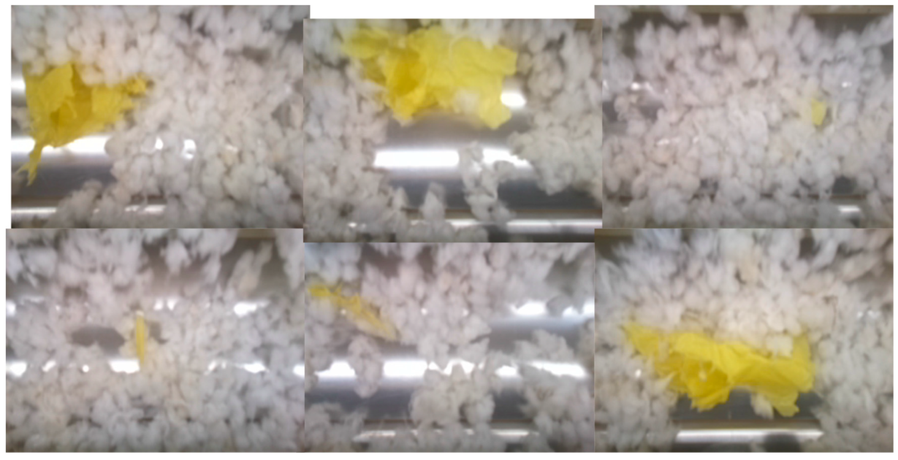

Figure 1. Plastic contamination images, captured by the prototype camera system

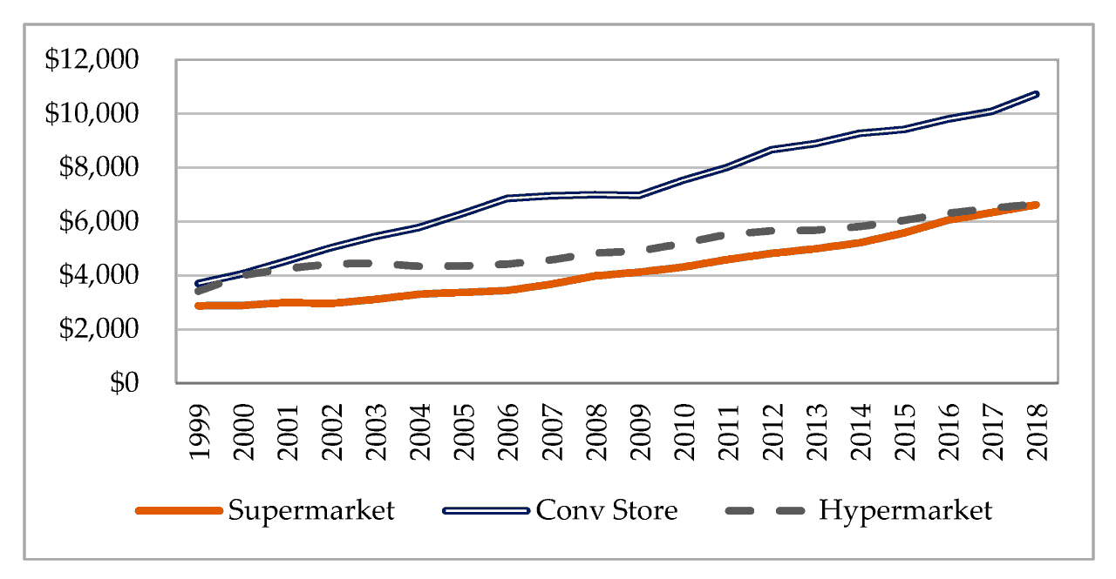
Fig.2. Sales volume of organized retailers (unit: million USD)

Table Sample

Table 2: Descriptive Statistics
Variable | Mean | Std. Deviation | Std. Error of Mean | Skewness | Kurtosis
AC | 3.90 | 0.837 | 0.06 | -0.341 | -0.871
REC | 3.76 | 0.898 | 0.06 | -0.898 | 0.552
EMP | 3.21 | 1.123 | 0.08 | -0.465 | -0.465
CD | 3.86 | 0.926 | 0.07 | -0.588 | -0.322
PJ | 3.68 | 1.052 | 0.07 | -0.543 | -0.582
DJ | 3.27 | 1.009 | 0.07 | -0.195 | -0.660

REFERENCES [APA 6th Edition]

Lavy, S. (2019). Daily Dynamics of Teachers' Organizational Citizenship Behavior: Social and Emotional Antecedents and Outcomes. Frontiers in psychology, 10 (2), 28-63. https://doi.org/10.3389/fpsyg.2019.02863
Dunn, E. W., Aknin, L. B., & Norton, M. I. (2008). Spending money on others promotes happiness. Science Report, 3 (9), 1687–1688. https://doi.org/10.1126/science.1150952

